**AMERICAN INTERNATIONAL UNIVERSITY–BANGLADESH (AIUB)**

FACULTY OF ENGINEERING

Course name: Data Communication

Course code: COE 3201

Section: H

Semester: Spring 2023-24

Name: Farjana Yesmin Opi

ID: 22-47018-1

Instructor name: Dr. Muhammad Morshed Alam

Experiment no: 01

Experiment name: Introduction to MATLAB

Submission date: 10-02-2024

Performance Task for Lab Report: (your ID = AB-CDEFG-H)

**Generate two CDEF hertz sinusoids with different amplitudes and phases.

x1(t) = A1 cos(2π(CDEF)t + j1) x2(t) = A2 cos(2π(CDEF)t + j2)

(a) Select the value of the amplitudes as follows: let A1 = AB and A2 = GH. For the phases, use j1

= DG (in degrees), and take j2 = 30º. When doing computations in Matlab, make sure to convert

degrees to radians.

ID : 22-47018-1 (AB-CDEFG-H)

AB = 22(A1), GH = 81 (A2)

CDEF = 4701 (F)

DG = 78 (J1)

J2 = 30

(b) Make a plot of both signals over a range of t that will exhibit approximately 3 cycles. Make

sure the plot starts at a negative time so that it will include t = 0, and make sure that you have at

least 20 samples per period of the wave.

|  |  |
| --- | --- |
| MATLAB Code | Figure |
| %{  ID = 22-47018-1 AB-CDEFG-H  AB = 22  GH = 81  CDEF = 4701  DG = 78  %}  t = linspace(-3, 3,90);  CDEF = 4701;  A1 = 22;  ph_deg01 = 78;  ph_rad01 = deg2rad(ph_deg01);  x1 = A1*sin(2*pi*CDEF*t + ph_rad01);  figure;  plot(t, x1)  xlabel('t')  ylabel('X1')  title('This is plot of sin function')  grid on;    %{  ID = 22-47018-1 AB-CDEFG-H  AB = 22  GH = 81  CDEF = 4701  DG = 78  %}  A2 = 81;  ph_deg02 = 30;  ph_rad02 = deg2rad(ph_deg02);  x2 = A2*cos(2*pi*CDEF*t + ph_rad02);  figure;  plot(t, x2)  xlabel('t')  ylabel('X2')  title('This is the plot of cos function')  grid on; |  |

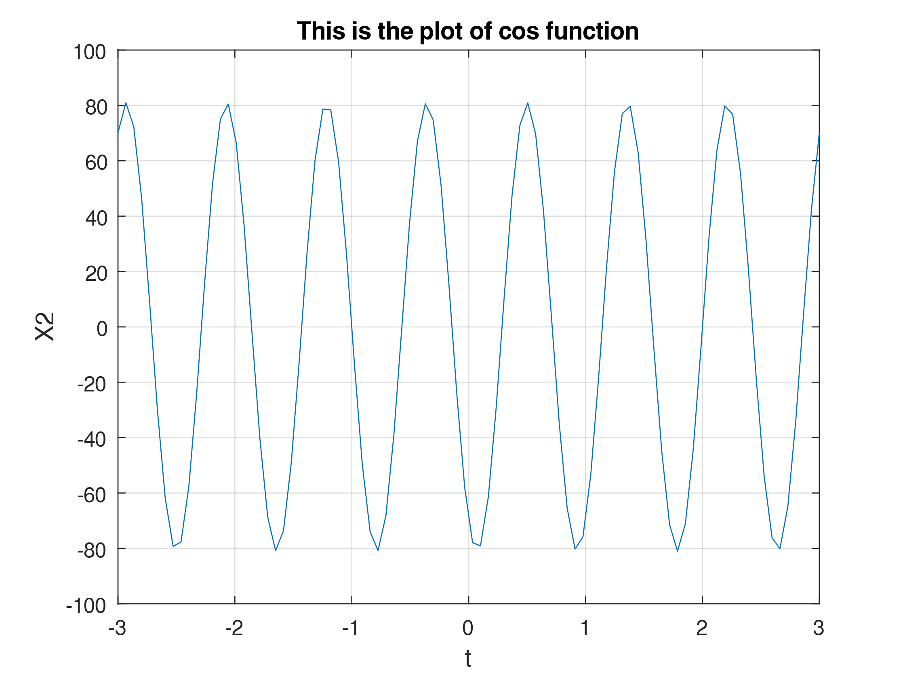

(c) erify that the phase of the two signals x1(t) and x2(t) is correct at t = 0, and also verify that

each one has the correct maximum amplitude.

|  |  |
| --- | --- |
| MATLAB Code | Figure |
| %{  ID = 22-47018-1 AB-CDEFG-H  AB = 22  GH = 81  CDEF = 4701  DG = 78  %}  t = linspace(-3, 3,90);  CDEF = 4701;  A1 = 22;  ph_deg01 = 78;  ph_rad01 = deg2rad(ph_deg01);  x1 = A1*sin(2*pi*CDEF*t + ph_rad01);  figure;  plot(t, abs(x1))  title('Amplitude plot of x1')  ylabel('Amplitude')  xlabel('t')  grid on;    figure;  plot(t, angle(x1))  title('Angle plot of x1')  grid on    %{  ID = 22-47018-1 AB-CDEFG-H  AB = 22  GH = 81  CDEF = 4701  DG = 78  %}  A2 = 81;  ph_deg02 = 30;  ph_rad02 = deg2rad(ph_deg02);  x2 = A2*cos(2*pi*CDEF*t + ph_rad02);  figure;  plot(t, abs(x2))  title('Amplitude plot of x2')  ylabel('Amplitude')  xlabel('t')  grid on      figure;  plot(t, angle(x2))  title('Angle plot of x2')  grid on |  |

(d) Use subplot(3,1,1) and subplot(3,1,2) to make a three-panel subplot that puts both of

these plots on the same window. See help subplot.

|  |  |
| --- | --- |
| MATLAB Code | Figure |
| %{  ID = 22-47018-1 AB-CDEFG-H  AB = 22  GH = 81  CDEF = 4701  DG = 78  %}  t = linspace(-2, 2,40);  CDEF = 4701;  A1 = 22;  ph_deg01 = 78;  ph_rad01 = deg2rad(ph_deg01);  x1 = A1*sin(2*pi*CDEF*t + ph_rad01);  subplot(3, 1, 1)  plot(t, x1)  xlabel('t')  ylabel('X1')  title('This is plot of sin')  grid on;  %{  ID = 22-47018-1 AB-CDEFG-H  AB = 22  GH = 81  CDEF = 4701  DG = 78  %}  A2 = 81;  ph_deg02 = 30;  ph_rad02 = deg2rad(ph_deg02);  x2 = A2*cos(2*pi*CDEF*t + ph_rad02);  subplot(3, 1, 2)  plot(t, x2)  xlabel('t')  ylabel('X2')  title('This is the plot of cos function')  grid on; |  |

(e) Create a third sinusoid as the sum: x3(t) = x1(t) + x2(t). In Matlab this amounts to summing the

vectors that hold the samples of each sinusoid. Make a plot of x3 (t) over the same range of time

as used in the previous two plots. Include this as the third panel in the window by using subplot

(3,1,3).

|  |  |
| --- | --- |
| MATLAB Code | Figure |
| %{  ID = 22-47018-1 AB-CDEFG-H  AB = 22  GH = 81  CDEF = 4701  DG = 78  %}  t = linspace(-2, 2,40);  CDEF = 4701;  A1 = 22;  ph_deg01 = 78;  ph_rad01 = deg2rad(ph_deg01);  x1 = A1*sin(2*pi*CDEF*t + ph_rad01);  subplot(3, 1, 1)  plot(t, x1)  xlabel('t')  ylabel('X1')  title('This is plot of sin')  grid on;    %{  ID = 22-47018-1 AB-CDEFG-H  AB = 22  GH = 81  CDEF = 4701  DG = 78  %}  A2 = 81;  ph_deg02 = 30;  ph_rad02 = deg2rad(ph_deg02);  x2 = A2*cos(2*pi*CDEF*t + ph_rad02);  subplot(3, 1, 2)  plot(t, x2)  xlabel('t')  ylabel('X2')  title('This is the plot of cos function')  grid on;      x3 = x1 + x2;  subplot(3, 1, 3);  plot(t, x3, 'r');  xlabel('t')  ylabel('x3')  title('THis is x3 = x1 + x2')  grid on |  |